

**LOCAL TRAIN TICKETING APPLICATION**

**Software Requirement Specification (SRS) Document**

**Group-7**

**Sprint Implementation**

**Project Timeline**

**20.10.2022 to 27.10.2022**

**INDEX**

**1. Introduction**

1.1 Purpose ------------------------------------------------- 4

1.2 Intended audience -------------------------------------------------- 4

1.3 Intended use -------------------------------------------------- 4

1.4 Scope -------------------------------------------------- 4

**2. Overall description** -------------------------------------------------- 4

2.1 Assumptions and dependency -------------------------------------------------- 5

**3. System features and requirements**  -------------------------------------------------- 5

**3.1 Functionality**  -------------------------------------------------- 5

3.1.1 Admin_Access -------------------------------------------------- 5

3.1.2 User_Information -------------------------------------------------- 5

3.1.2.1 Register_data -------------------------------------------------- 5

3.1.2.2 Edit_data --------------------------------------------------5

3.1.2.3 Delete_data --------------------------------------------------6

3.1.2.4 View_data --------------------------------------------------6

3.1.3 Train_Maintainance -------------------------------------------------- 5

3.1.3.1 Add_data -------------------------------------------------- 5

3.1.3.2 Edit_data -------------------------------------------------- 5

3.1.3.3 Delete_data -------------------------------------------------- 6

3.1.3.4 View_data -------------------------------------------------- 6

3.1.4 User_validation ------------------------------------------------- 6

3.1.5 Reports ------------------------------------------------ 6

3.1.5.1 Max_booking_report ----------------------------------------------- 6

3.1.5 .2 Min_Balance_Condition --------------------------------------------- 6

3.1.6 Login_Condition ------------------------------------------------ 7

3.1.7 Ticket_Booking ----------------------------------------------- 7

3.1.7.1 Daily_fare_condition -------------------------------------------------- 7

3.1.7.2 Monthly_fare_condition -------------------------------------------------- 7

3.1.7.3 Monthly_deposit_money -------------------------------------------------- 7

3.1.7.4 Low_Deposit -------------------------------------------------- 6

3.1.8 View_Report -------------------------------------------------- 6

3.1.8.1 view_min_balance -------------------------------------------------- 5

3.1.8.2 User_booking_confirmation ----------------------------------------------- 7

3.1.9 Train_Capacity ------------------------------------------------- 7

**3.2 System requirement** -------------------------------------------------- 8

3.2.1 Tools to be used --------------------------------------------------8

3.3 System feature -------------------------------------------------- 8

**4. Data Flow Diagram**

4.1 DFD level 0 ------------------------------------------------- 8

4.2 DFD level 1 ------------------------------------------------- 9

1. **Introduction**

The introduction of the software requirement specification provides an overview of the entire software. The entire SRS with overview description purpose, scope, tools used and basic description. The aim of this project is to allow users to book local train tickets and get ticket receipts online. The detailed requirements of the **Local Train Ticketing application** are provided in this document.

**1.1** **Purpose**: **-**The purpose of this document is to show the requirements for the Local Train Ticketing application, in which it allows the user to register, login and get a ticket online, print it and travel by train.

**1.2** **Intended Audience: -**This document is intended to be read by User.

**1.3** **Intended Use: -**

* Designer
* Developer
* User

Since this general-Purpose Software anyone can access it.

* 1. **Scope: -**This project aims to create the development of a Local Train Ticketing application. The ticketing process consists of a ticket booking form. The user can reserve the train ticket by giving the required details like source, destination, and date of journey and knows the trains list.

The user can select a train and check availability. If available, the user can give details in the form, payment details and submit it for processing. The local train ticketing application provides train tickets which users can view and take a print.

**2. Overall description**

It is a local train ticketing system project for local trains that allows users to book local train tickets and get ticket receipts online. This local train project provides login rights for normal users and admin. A normal user may login and get a ticket online, print it and travel by train. The ticketing process consists of a ticket booking form.

The form allows the user to choose his source and destination. The source is the station from where the user will be boarding the train. Destination is the station he needs to get down at. The project database is already filled with stations.

The system also consists of an option to select whether ticket is a single journey, or a return ticket and the journey will be commenced in first class or second class. It also consists of an admin account. The admin may recharge user account balance and check for various journey tickets processed in the system.

**2.1** **Assumptions and Dependency: -**

* System should have Ubuntu Linux installed.
* The system should have either 4GB or more RAM.
* The service is used preferably on a desktop or laptop or mobile.

**3. System Features and Requirements: -**

**3.1 Functionality: -**

**3.1.1 LTT_01->Admin_Access:** The admin access to the system would be password authenticated.

**3.1.2 LTT_02->User_Information:** The user of the system needs to register to use the system.

**3**.**1.2 LTT_02.01->Register_data:** Users can add data which consists of Aadhaar number, name, password, Phone number, gender.

**3**.**1.2 LTT_02.02->Edit_data:** Users can edit data which consists of Aadhaar number, name, password, Phone number, gender.

**3**.**1.2 LTT_02.03->Delete_data:** Users can delete data which consists of Aadhaar number, name, password, Phone number, gender.

**3**.**1.2 LTT_02.04->View_data:** Users can delete data which consists of Aadhaar number, name, password, Phone number, gender.

**3.1.3 LTT_03->** **Train_Maintainance:** This is the first main menu level function that provides flexibility to enable the user to do modifications inside the database. It allows you to Add, Edit, Delete and View contents or records of the database.

**3**.**1.3 LTT_03.01->Add_data:** Admin can add records of train database which consists of train name, source. Destination, distance in km, capacity in numbers, fare per km.

**3**.**1.3 LTT_03.02->Edit_data:** Admin can edit records of train database which consists of train name, source. Destination, distance in km, capacity in numbers, fare per km.

**3**.**1.3 LTT_03.03->Delete_data:** Admin can delete records of train database which consists of train name, source. Destination, distance in km, capacity in numbers, fare per km.

**3**.**1.3 LTT_03.04->View_data:** Admin can view records of train database which consists of train name, source. Destination, distance in km, capacity in numbers, fare per km.

**3.1.4 LTT_04->User_Validation:** While registering the user must enter his Aadhaar no which is unique. He/ She also must enter personal details. He/ She must choose a password which will be used for availing the services.

**3.1.5 LT_05->Reports:** The admin can view the report.

**3.1.5 LTT_05.01->Max_Booking_Report:** A mreport is available for the train for which the maximum bookings are done.

**3.1.5 LTT_05.02->Min_Balance_Condition:** While registering the user needs to deposit a minimum balance of RS.500/- which will be adjusted against bookings.

**3.1.6 LTT_06->** **Login_Condition:** Tobook a ticket the user needs to login using his/her aadhaar no and password which will be authenticated.

**3.1.7 LTT_07->** **Ticket_Booking:** Make journey is an option which is available at station. A registered user goes there and enters his Aadhar and password. Based on his record his ticket is printed. Automatically the fare is deducted from his deposit.

Based on the ticket booking, whether it is daily or monthly, the fare should be calculated.

**3.1.7LTT_07.0-1>Daily_Fare_Condition:**On entering the source and destination the system automatically shows the list of trains and their number. The user needs to choose one. The user can go for a daily ticket in which case the fare is calculated for a day and displayed.

**3.1.7 LTT_07.02-> Monthly_Fare_Condtion:** If a user goes for a monthly ticket, then he/she gets 20% discount on the monthly charge which is displayed and stored.

**3.1.7 LTT_07.03->** **Monthly_Deposit_money:** In case it’s a monthly ticket then the deposit money is adjusted against it.

**3.1.7 LTT_07.04->Low_Deposit:**When the user deposit is reduced to RS.100/- or less automatically the user gets a message, and he can re-deposit more money. If insufficient balance is there in his/her account, then the ticket is denied.

**3.1.8 LTT_08->** **View_Report**: A report can be generated which shows the details of all users

**3.1.8 LTT_08.01->** **View_min_Balance:** The admin can see a report of all users whose balance is <= Rs. 100.

**3.1.8LTT_08.02->** **User_Booking_Confirmation:** Once the registration is successful a confirmation is given to the user that he/she can now start booking.

**3.1.9LTT_09->Train_Capacity:**The capacity of a train can be increased/decreased by the admin.

**3.2 System Requirements: -**

### **3.2.1. Tools to be used:**

* C File Handling
* C-Language
* Val grind
* Splint
* Make

### **3.3 System Features: -**

### **Supportability**:Usage of the system is easy.

* + - **Design Constraints**: The system is built using only C language.
    - **Usability:** Local Train ticket application is essential for booking the train ticket for the user. This local train ticketing application is the process of registering into the database and giving some details and booking the ticket as per the availability.

The application needs some details of the user like Aadhaar card etc., After booking the ticket user can view it and take print.

* + - **Reliability & Availability:** The system is available 24/7, that is whenever the user would like to use the system, they can use it up to its functionalities.

### **Performance**: The system will work on the user’s terminal**.**

1. **Data Flow Diagram**

**4.1 DFD Level 0**

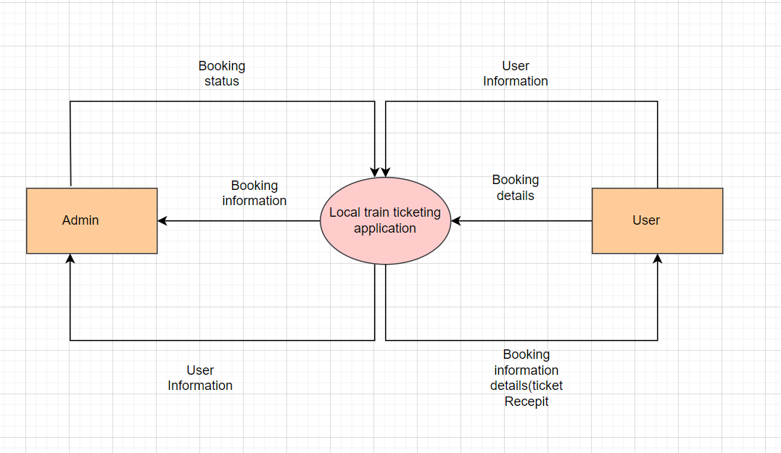

* 1. **DFD Level 1**

